BBA SEM-2

Session:2023-24

Tally

Bansal & Sons

**Submitted By- Submitted To-**

**Shankh Bansal Dr. Gaurav Bagra**

**Vani Saxena**

Tally

Bansal & Sons

Step 1: Create a Company- To use Tally, you need to create a company first. You can do this by selecting the “Create Company” option from the Gateway of Tally screen. Here, you will be prompted to enter details like company name, address, financial year, and other necessary information. Like in my case i have created a company Name Bansal & Sons.

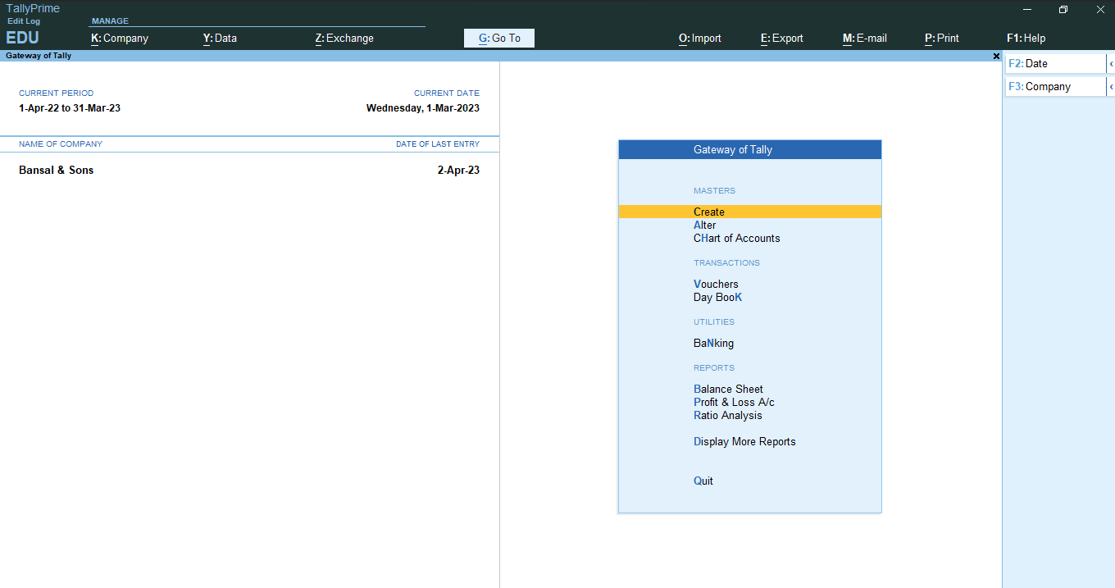

Step 2: Set up accounts: Once the company is created, you can set up different accounts such as cash, bank, sales, purchase, expenses, and so on. You can do this by selecting the “Accounts Info” option from the Gateway of Tally screen and then choosing the type of account you want to create.

3- After Creating All Ledger, the list of accounts automatically display.

Step 4- Record transactions: To record a transaction, you can select the relevant voucher type such as payment, receipt, sales invoice, purchase invoice, and so on. You will be prompted to enter the details of the transaction such as the date, the party’s name, the amount, and the account involved.

This Function(f) Key helps in passing the Entry.

F4 – Contra F5 – Payment F6 - Receipt F7 – Journal F8 -Sales F9-Purchase

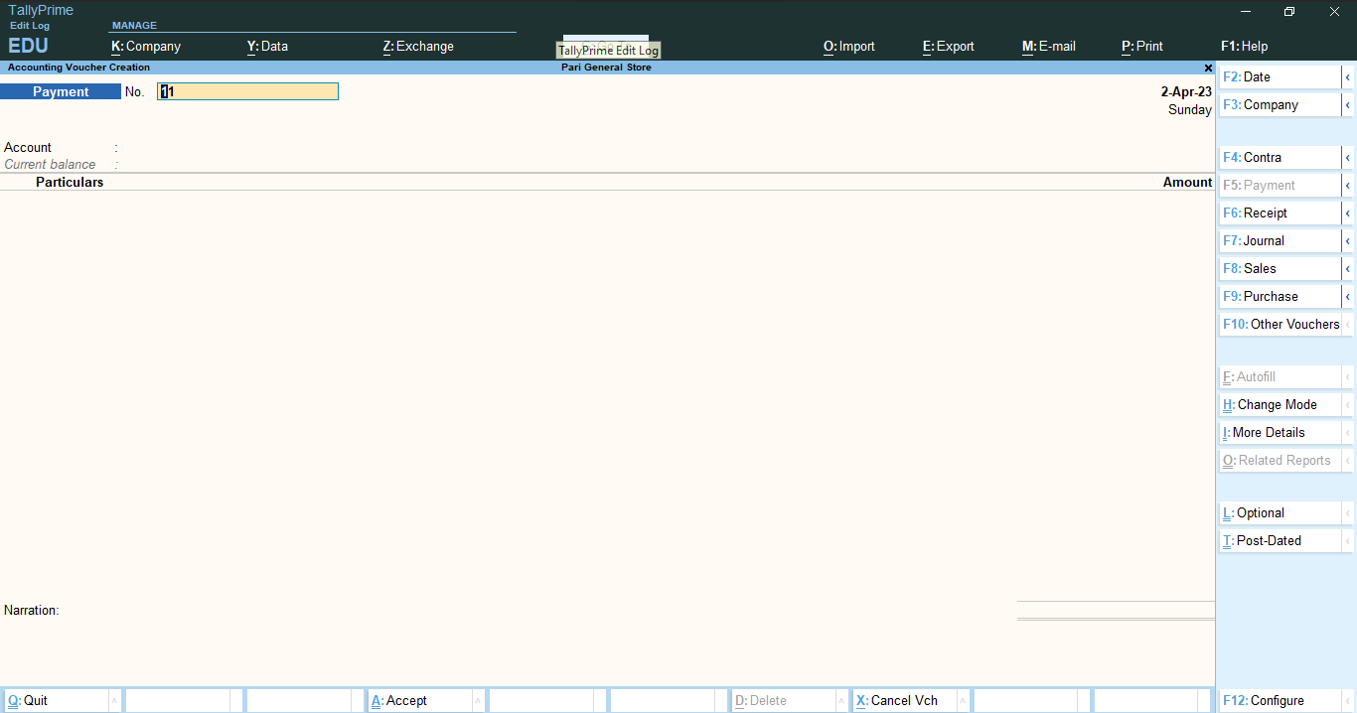

Steps 5- View reports: Tally provides various reports to give you a better understanding of your business's financial health. You can access these reports by selecting the “Display” option from the Gateway of Tally screen and then choosing the report you want to view.

***Trial Balance***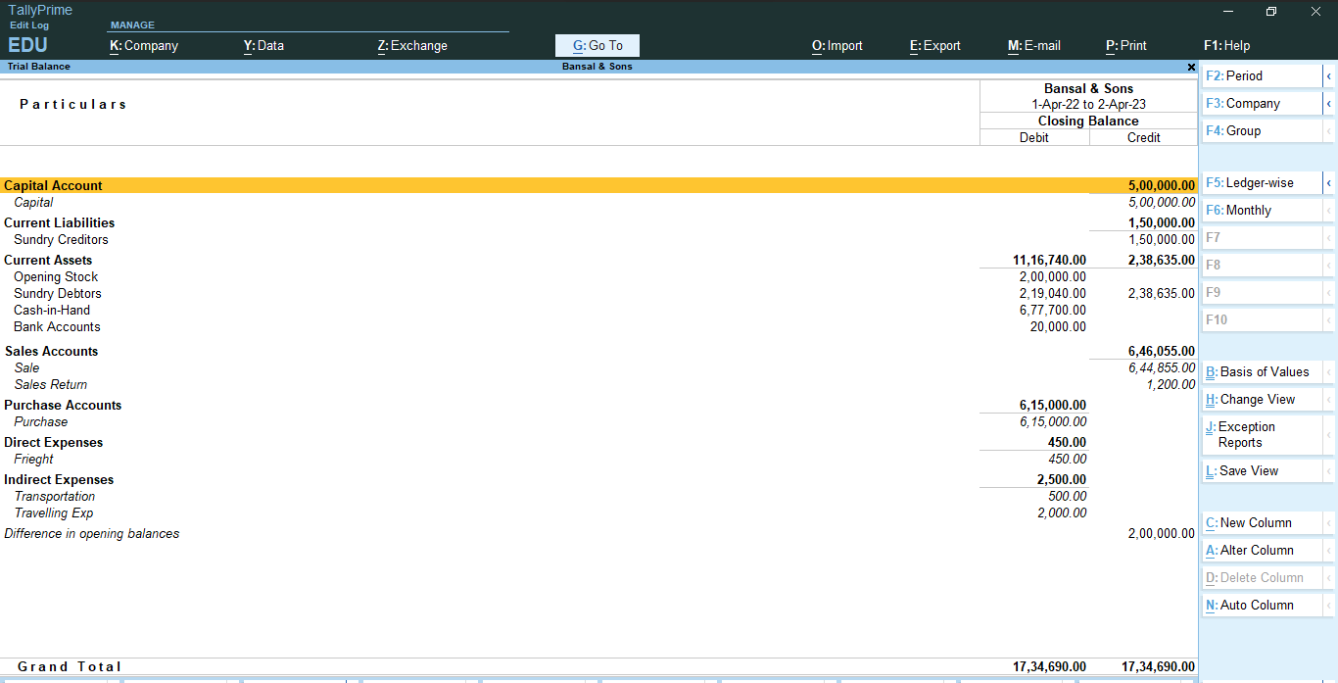

***Day Book***

***Balance Sheet***

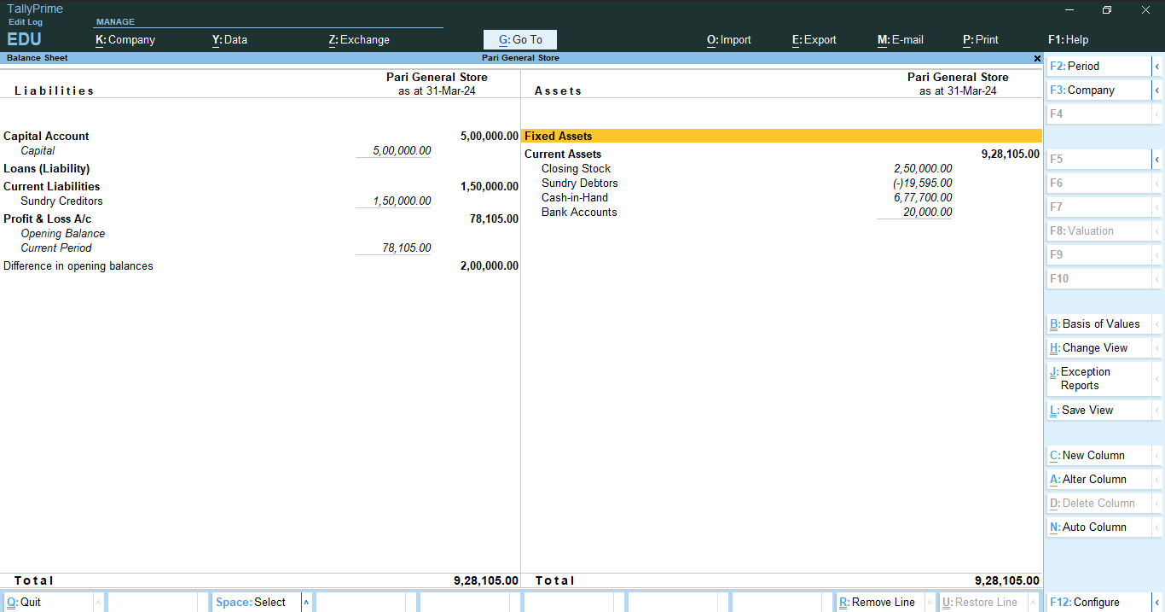

***Profit & Loss***

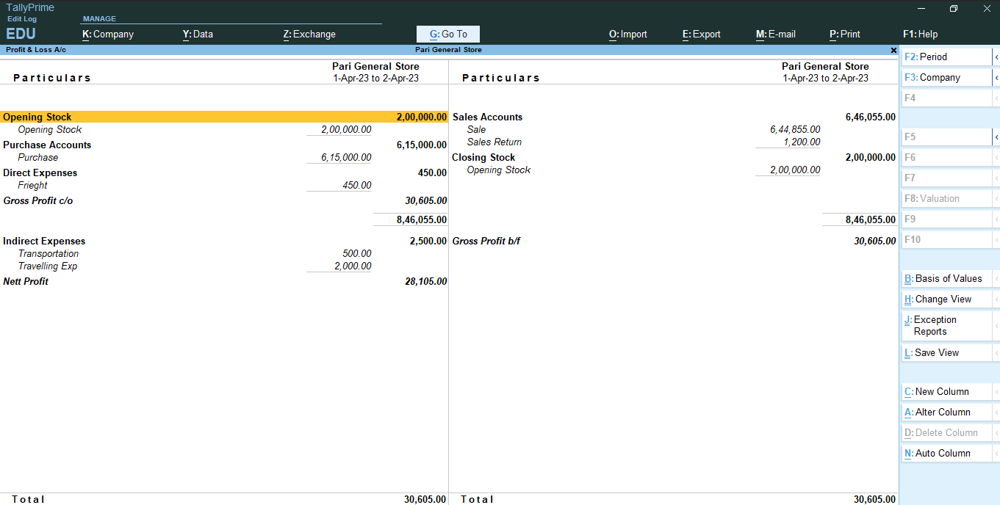

Ratio Analysis